# Document History

The master version of this document is stored by TfL in the FTP TFS Source Control at; $/Deployment/Main/Documents.

Any version of this document not from this location is not controlled.

|  |  |  |  |
| --- | --- | --- | --- |
| **Date** | **Version** | **Changes** | **Changed By** |
| 26/03/2014 | 1 | Released | Nitin Chadha |
|  |  |  |  |

AppFabric Installation Guide for SSO & FAE functional rigs

**Prerequisite**

* Windows Server 2008 Enterprise or DataCenter Editions.Requires .NET 4.0
* AppFabric 1.1
* Power Shell
* SQL Server Instance (optional)
* Service account –
  + FAELAB\zsvcappfab for AppFabric rigs
  + faelab\zsvcfae for FAE rigs
* If using SQL server as the configuration host (Refer Fig2a), make sure the SQL Server Database is available and AppFabric Service account has db_datawriter and db_reader access.
* If using the filesystem share to store the configuration file the step above is not required. Instead refer Fig 2b. For FAE we have started using the file system share folder to store the configuration files.
* Stop the IIS
* Install AppFabric Caching Software

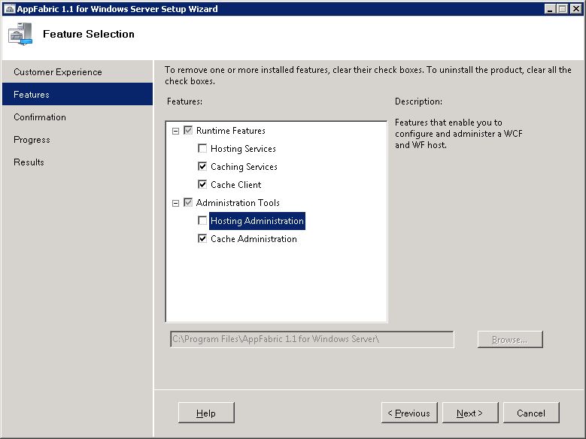

(Fig1)

* Start the IIS service
* Setup AppFabric server configuration
* Create the Database for Appfabric Configuration (only when using DB to host configurations) Fig.3

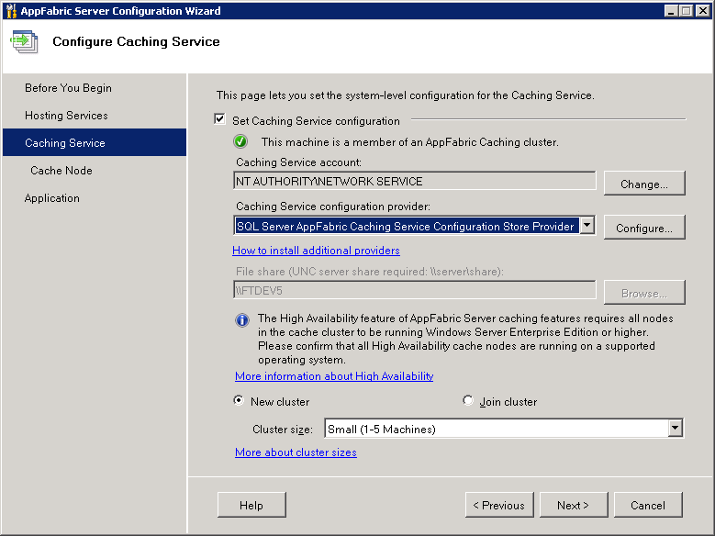

(Fig2a)

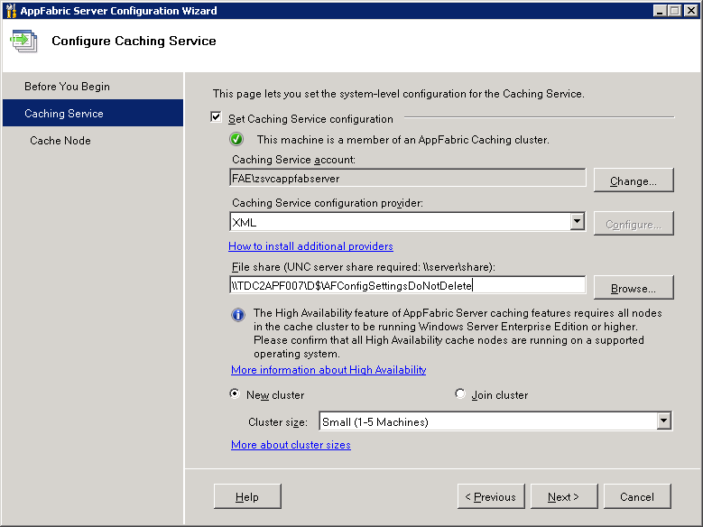

(Fig 2b)

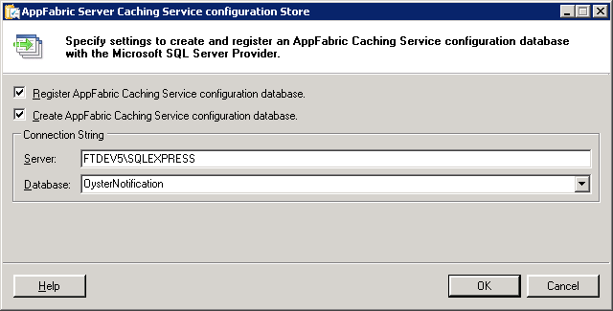

(Fig3)

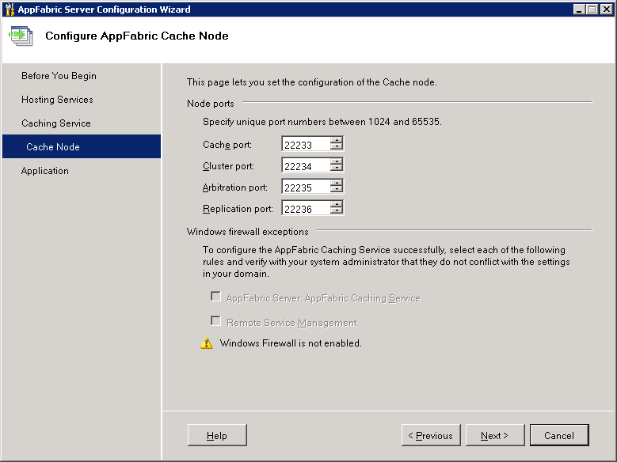

(Fig4)

* Grant Permissions to the IIS Application using Caching Administration Windows PowerShell

Grant-CacheAllowedClientAccount FAELAB\zsvcappfab (for SSO)

or

Grant-CacheAllowedClientAccount faelab\zsvcfae (for FAE)

Create new cache by using – New-Cache SSO or New-Cache FAEIntraday

* Set the cache timeout to 20 minutes ( if required otherwise set it through the .Net Application using AppFabric caching api)
* Start the cache cluster
* Check the IIS websites are running as expected.

Basic tasks and Support

* To check if the cachecluster is up and running.  
    
  Run Get-CacheHost
* To Stop/Start the AppFabric Caching - Open powershell for AppFabric  
    
  Run Stop-CacheCluster or Start-CacheCluster

(Stop the Caching using the command above if you are permanently disabling the AppFabric caching)

* To check for number of items stored in the AppFabric Cache  
    
  Run Get-CacheStatistics SSO  
    
  or Get-CacheStatistics FAEIntradayHA

* If you are installing AppFabric for the first time, make sure to install cumulative rollup afterwards: <http://support.microsoft.com/kb/2716015/EN-US>
* The service account which is being used to run the service must be setup on the DB with Read/Write and Execute on the same.
* Note: **DO NOT** Stop/Start the AppFabric caching host service from the Service Control Manager.